**Dashboard Design**

|  |  |
| --- | --- |
| Date | 6 October 2025 |
| Team ID | xxxxxx |
| Project Name | Predicting Plant Growth Stages with Environmental and Management Data Using Power BI |
| Maximum Marks | 5 Marks |

Creating an effective dashboard involves thoughtful design to ensure that the presented information is clear, relevant, and easily understandable for the intended audience. Here are some key principles and best practices for dashboard design

**Activity 1: Interactive and visually appealing dashboards**

Creating interactive and visually appealing dashboards involves a combination of thoughtful design, effective use of visual elements, and the incorporation of interactive features. Here are some tips to help you design dashboards that are both visually appealing and engaging for users so take care of below points

* Clear and Intuitive Layout
* Use Appropriate Visualizations
* Colour and Theming
* Interactive Filters and Slicers
* Drill-Down Capabilities
* Responsive Design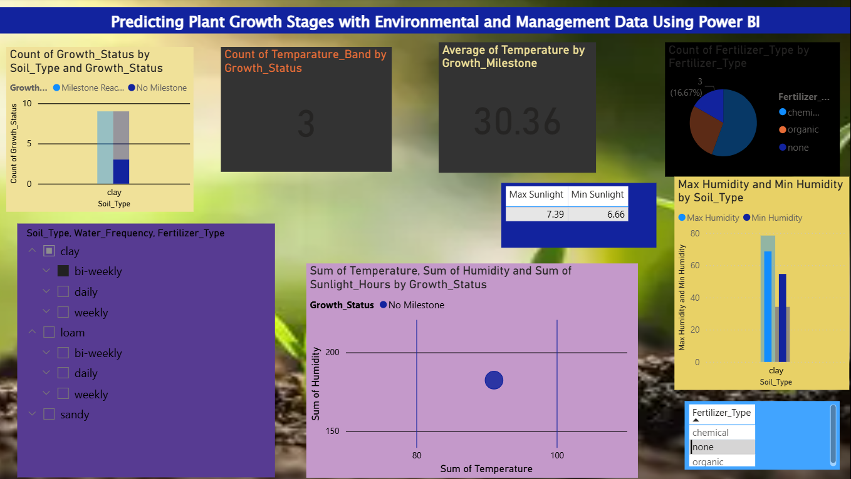
* Custom Visuals and Icons
* Use of Infographics

**Major Outcomes: Plant Growth Success Analysis**

The project successfully transformed raw data into a set of quantifiable insights and an interactive **Power BI dashboard**, directly fulfilling the objective of defining the optimal growth protocol for maximum success.

**1. Optimal Protocol and Environmental Benchmarks**

The analysis defined the specific inputs required to maximize the probability of reaching the Growth Milestone:

* **Optimal Environmental Cluster Identified (BQ-3):** The **Scatter Plot** visually defined the "sweet spot" for growth, showing that successful outcomes cluster within specific, precise ranges of **Temperature** and **Humidity**.
* **Target Temperature Quantified (BQ-5):** A dedicated **KPI Card** displays the **Average Optimal Temperature** associated with successful plants, providing a hard target for environmental control systems.
* **Protocol Ranking Established (BQ-1, BQ-2):** The **Clustered Bar Charts** ranked performance across categorical variables, revealing the **best-performing care protocol** (e.g., the specific combination of Soil Type, Water Frequency, and Fertilizer Type) that yields the highest success rate.

**2. Data Quality and Modeling Success**

The project achieved exceptional efficiency due to the high quality of the input data:

* **Data Completeness:** The raw data contained **zero missing values** across all 7 columns, eliminating the need for complex data imputation or cleaning.
* **Effective Data Transformation:** The preprocessing phase successfully created the necessary columns for advanced visualization, including the **Growth_Status** text column and the binned variables (e.g., **Sunlight_Hour_Bins**, **Temperature_Band**) used in the histograms.

**3. Solution Delivery and Usability**

The final deliverable is a highly functional and actionable tool for the end-user (Grower):

* **Actionable KPI Cards (BQ-4, BQ-5):** Two dedicated **Card visuals** provide the absolute count and success rate () of plants within the **Optimal Temperature Band**, serving as immediate performance validators.
* **Interactive Drill-Down Capability:** The dashboard's design ensures all visuals are linked to the three primary **Slicers** (, , ), allowing the grower to instantly test and compare any possible care protocol combination.
* **Boundary Conditions Defined (BQ-8):** A **Multi-Row Card** explicitly displays the **Minimum and Maximum Sunlight Hours** required by successful plants, providing the non-negotiable limits for light exposure.